SVN Tutorial
A trunk in SVN is main development area, where major development happens.
A branch in SVN is sub development area where parallel development on different functionalities happens. After completion of a functionality, a branch is usually merged back into trunk.
A tag in SVN is read only copy of source code from branch or tag at any point of time. tag is mostly used to create a copy of released source code for restore and backup.
Main concepts :
- Main actual code done in trunk and once development is done from developer end they have to follow below steps to create a new branch
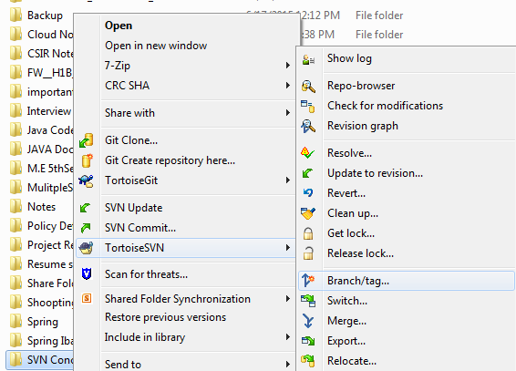

- Here we create a branch for that trunk code and need to select like below, and also need to select Head revision in the repository radio button and click ok

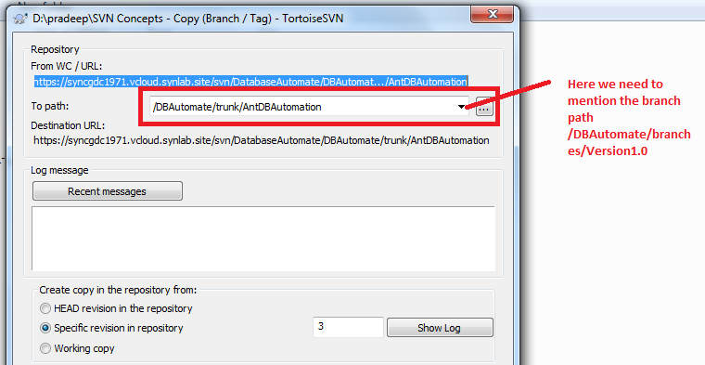

Then you can see a new branch is created.

- And from the branch you can create a tag like above steps. Right click branch project folder and choose tortoiseSVN and then select branch tag and point to tag folder

